
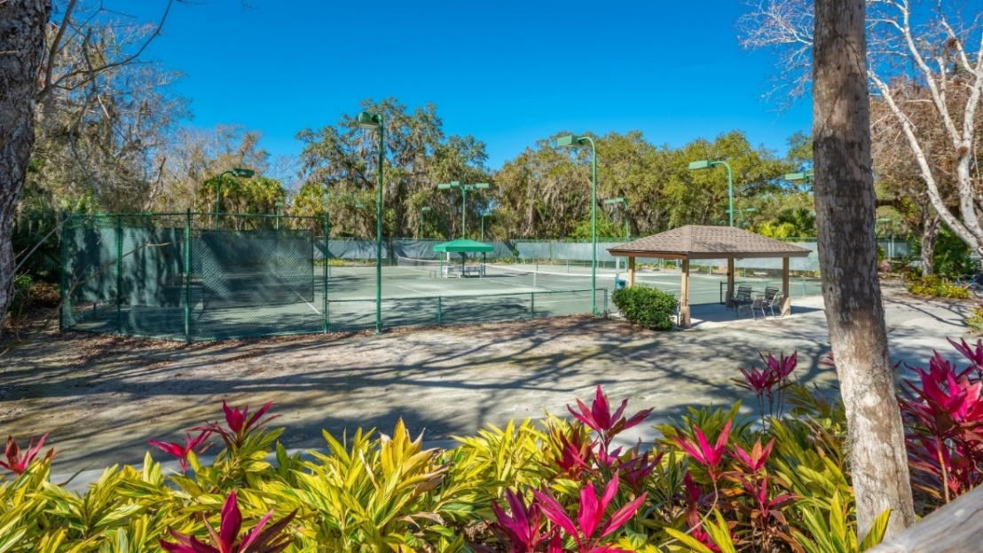

OPEN FOR PLAY!
The Meadows Tennis Proshop is located on 3100 Longmeadow, Sarasota FL 34235. Tennis Proshop staff can be reached by calling 941-415-9810 or by email at racquetsports@meadowsca.com

Members in Court Reserve should set up their Payment Profile to make processing payments (prior to play, in the tennis pro shop), as quick and seamless as possible.
IT’S EASY! - Go to https://app.courtreserve.com/Online/Portal/CreateAccountAndRequestAccessToOrg?id=13393
on your computer scan the QR code with your phone camera or search the App Store and install CourtReserve.
REGISTRATION – Choose The Meadows Tennis Sarasota and then register.
RESERVE A COURT – You must be registered to make or view court reservations. For assistance, please contact the Tennis Pro Shop.
SCAN THE CODE BELOW TO DOWNLAD THE APP!


Lessons and Clinics will be offered to both Residents and Non-Residents, card payments can be processed in the Tennis Pro Shop at the time of the Lesson/Clinic. Racquet Stringing Services and Pro Shop Merchandise are also being offered with Card Payment.

